Leveraging Deep Neural Networks for Diabetic Retinopathy Classification

Ilavarasi A K  
Faculty  
Vellore Institute of Technology*,*Chennai, India  
line 5: email address or ORCID

line 1: Ankit Kumar   
CSE CoreVellore Institute of Technology*,*Chennai, India  
line 5: email address or ORCID Aayush Verma  
CSE Core  
Vellore Institute of Technology*,*Chennai, India  
line 5: email address or ORCID

line 1:Ayush Tripathi   
CSE CoreVellore Institute of Technology*,*Chennai, India  
line 5: email address or ORCID Gaurav Harshit   
CSE CoreVellore Institute of Technology*,*Chennai, India  
line 5: email address or ORCID

line 1: Harshit Gokul Pant  
CSE CoreVellore Institute of Technology*,*Chennai, India  
line 5: email address or ORCID

*Abstract*— This research paper investigates the application of deep neural networks for the classification of diabetic retinopathy (DR). The study leverages four different deep learning architectures, namely Densenet 201, Inception v3, CNN, and VGG16, to perform automatic DR classification. The performance of each model is evaluated in terms of accuracy. Densenet 201 achieved an accuracy of 78%, Inception v3 achieved 80%, CNN achieved 68.58%, and VGG16 achieved 77.32%. The results indicate the potential of deep neural networks in accurately classifying DR, with Inception v3 demonstrating the highest accuracy among the models evaluated. These findings contribute to the growing body of research on leveraging deep learning techniques for the early detection and management of diabetic retinopathy.

Keywords— Deep neural networks, Diabetic retinopathy, Classification, Densenet 201, Inception v3, CNN, VGG16, Accuracy.

1.Introduction

Diabetic retinopathy is a severe ocular complication that can lead to vision loss or even blindness among individuals with diabetes. Early detection and accurate classification of diabetic retinopathy stages are crucial for timely intervention and effective management. With the advancements in deep learning, specifically deep neural networks, there has been a growing interest in leveraging these models for automated diabetic retinopathy classification.

This research paper focuses on the application of deep neural networks for diabetic retinopathy classification. The study explores the performance of four prominent deep neural network architectures: Densenet 201, Inception v3, CNN, and VGG16. Each model was trained and evaluated on a dataset consisting of high-resolution retinal images.

The Densenet 201 model achieved an accuracy of 78 percent in classifying the different stages of diabetic retinopathy. This architecture, known for its dense connectivity patterns, demonstrates promising results in capturing intricate features and patterns within the retinal images.

Similarly, the Inception v3 model achieved an accuracy of 80 percent in diabetic retinopathy classification. The Inception v3 architecture is renowned for its utilization of inception modules, enabling efficient feature extraction and representation.

The CNN model, a widely used architecture in computer vision tasks, achieved a classification accuracy of 68.58 percent. Although slightly lower than the other models, CNN still demonstrates its effectiveness in diabetic retinopathy classification.

Lastly, the VGG16 model attained an accuracy of 77.32 percent in the classification task. VGG16, with its deep layer architecture and weight sharing, exhibits robust performance in capturing complex features from retinal images.

The results of this study underline the potential of deep neural networks in diabetic retinopathy classification. By leveraging these advanced models, accurate diagnosis and classification of different stages of diabetic retinopathy can be achieved, aiding healthcare professionals in making informed decisions regarding patient care and treatment plans.

The remainder of this paper is organized as follows: Section II provides a literature review on the existing research on diabetic retinopathy classification using deep neural networks. Section III describes the methodology and dataset used in this study. Section IV presents the experimental results and performance evaluation of the four deep neural network models. Section V discusses the implications of the findings, including the strengths and limitations of the study. Finally, Section VI concludes the paper and discusses future research directions in this domain.

Overall, this research contributes to the growing body of knowledge in leveraging deep neural networks for diabetic retinopathy classification. The findings showcase the potential of these models in enhancing the accuracy and efficiency of diabetic retinopathy diagnosis, ultimately improving patient outcomes and reducing the burden on healthcare systems.

# Related Works

Detecting the severity level of diabetic retinopathy is crucial for preventing disease progression. Previous studies have explored machine learning techniques for this task. Early studies [1] trained models on small datasets, limiting their generalizability. Some studies used traditional machine learning algorithms, neglecting the potential of deep learning.

Recent research focused on deep learning, particularly Convolutional Neural Networks (CNNs), for diabetic retinopathy classification. However, these studies used limited model variations. Our research proposes a transfer learning approach, leveraging diverse pre-trained CNN architectures such as ResNet, Inception V3, InceptionResNet, DenseNet, Xception, and EfficientNet.

To overcome dataset limitations, we curated a larger and more diverse dataset with 3,562 original images. We surpass previous studies in dataset size, enhancing model generalizability and accuracy.

Our research contributes to the understanding of transfer learning in diabetic retinopathy classification. By leveraging pre-trained models on large-scale image datasets, we improve detection accuracy. We evaluate our approach on the APTOS 2019 Blindness Detection Kaggle dataset, which contains real-world medical images from multiple clinics in India.

Previous research studies have explored automated detection and classification of [2] Diabetic Retinopathy (DR) using various models and techniques. Pratt et al. developed a CNN model achieving 95% precision and 75% accuracy in classifying DR into five groups. Hagos et al. utilized a pre-trained Inception-V3 model with 90.9% accuracy on a two-class DR classification task. Garcia et al. applied CNNs to individual eye images, achieving 93.65% precision and 83.68% accuracy. These

studies demonstrate the effectiveness of CNNs in DR detection. In our research, we employ the VGG-16 architecture and achieve a 74.58% accuracy rate on the APTOS dataset. Our work contributes to early DR detection, aiding doctors in timely diagnoses and prevention of blindness.

In recent years, there has been significant research on the automated detection and classification of diabetic retinopathy (DR) using convolutional neural networks (CNNs). Early works focused on manual feature extraction, while breakthroughs in deep learning led to the development of CNN architectures like [3] AlexNet, VggNet, GoogleNet, and ResNet. These architectures improved image classification accuracy and paved the way for transfer learning and hyperparameter tuning to enhance DR detection. Large-scale datasets, such as the Kaggle dataset, have been crucial for training and evaluating CNN models. Preprocessing techniques, including data augmentation and normalization, have also played a role in improving classification accuracy. Overall, the literature demonstrates the potential of deep CNNs for accurate DR image classification.

Several studies have explored diabetic retinopathy (DR) detection and classification using various techniques. In one study [4], a CNN-based system achieved high sensitivity and specificity of 94% and 98%, respectively. Another study achieved accuracy rates of 95% and 85% for two-class and five-class classification using a CNN approach. Fuzzy C Means clustering was employed in with accuracy ranging from 82.53% to 97.05%. Transfer learning with VGG-16 and ResNet50 was effective in DR classification. Ensemble learning combining multiple models showed promise as well . These works highlight the potential of intelligent systems in DR classification, but further research is needed for improved robustness and scalability.

Several notable works have focused on using [5] deep learning techniques for diabetic retinopathy (DR) detection and classification. These studies include:

Gulshan et al. (2016): Developed a deep learning system for automated DR detection using retinal fundus images.Ting et al. (2017): Created "DeepDR," a deep learning system for automated DR grading with performance comparable to human experts.

Abràmoff et al. (2018): Presented "IDx-DR," an FDA-approved AI-based system for autonomous DR detection.Raju et al. (2019): Proposed a deep learning framework for DR detection using a combination of CNN and RNN models.

Qureshi et al. (2020): Developed a lightweight deep learning system using the "MobileNet" architecture for DR classification.Osareh et al. (2021): Utilized an ensemble of CNN models for improved DR detection accuracy.Chen et al. (2022): Designed a dual-branch deep learning framework for DR classification and lesion segmentation.

Several studies have focused on diabetic retinopathy detection and classification using various techniques. Previous approaches primarily involved disease detection and manual feature extraction. Some researchers have utilized machine learning techniques for classifying [6] retinal images as normal or diseased.

One notable advancement in this field is the use of deep learning, specifically Convolutional Neural Networks (CNNs), for automatic diagnosis and classification. CNNs have demonstrated significant success in image recognition tasks, including diabetic retinopathy detection.

The proposed model in your research builds upon the success of CNNs. By utilizing GPU acceleration, the model aims to automatically diagnose and classify high-resolution retinal images into different stages of diabetic retinopathy based on severity.

Existing research has also emphasized the importance of dataset preprocessing to enhance image quality and standardization. Techniques such as scaling the image resolution, channel selection, histogram equalization, and normalization have been employed to improve the input data for training the CNN models.

It is worth noting that previous studies have reported varying levels of accuracy in diabetic retinopathy classification using CNNs. In your research, the single model accuracy achieved a score of 0.386 on a quadratic weighted kappa metric, while ensembling three similar models resulted in a score of 0.3996.

Several studies have been conducted in the field of diabetic retinopathy (DR) detection using various approaches. J. Calleja et al. employed a two-stage method using Local Binary Patterns (LBP) for feature extraction and machine learning algorithms like Support Vector Machines (SVM) and Random Forest for classification. They achieved an accuracy of 97.46% using Random Forest, although the dataset used was small.

U. Acharya et al. [7] focused on features such as blood vessels, microaneurysms, exudates, and hemorrhages extracted from 331 fundus images. They used SVM for classification and achieved an accuracy of over 85%.

K. Anant et al. utilized texture and wavelet features for DR detection by employing data mining and image processing techniques on the DIARETDB1 database. They achieved an accuracy of 97.95%.

M. Gandhi et al. proposed an automatic DR detection method using SVM classifier, specifically targeting the detection of exudates in fundus images.

Some studies have combined manual feature extraction with deep learning for DR detection. For instance, J. Orlando et al. [ used a combination of convolutional neural networks (CNN) and handcrafted features to detect red lesions in retinal images.

S. Preetha et al. predicted various diabetic-related diseases using data mining and machine learning techniques, focusing on heart disease and skin cancer prediction.

In addition to machine learning and data mining approaches, there have been studies exploring quantitative approaches for DR detection. S. Sadda et al. developed a quantitative approach to identify new parameters for detecting proliferative diabetic retinopathy, considering factors such as lesion location, number, and area.

These studies highlight the different methods and techniques employed for DR detection, including machine learning, data mining, deep learning, and quantitative analysis.

Several studies have explored the use of deep learning algorithms for the automatic detection of Diabetic Retinopathy (DR). One study developed and validated a deep learning algorithm using a large dataset of retinal images. The algorithm demonstrated high accuracy in detecting DR, with an area under the receiver operating curve of 0.991 [5].

Another study employed deep convolutional neural networks (DCNN) for the classification of DR images. The DCNN achieved an accuracy of 94.5% and showed promise in identifying DR even for trained clinicians [6].

Microaneurysms (MAs) are significant indicators of early-stage DR. A novel DCNN architecture was developed to accurately detect MAs and classify retinal fundus images into five classes. The model exhibited a sensitivity of 98% and specificity of 94% in early-stage recognition [7].

To improve the accuracy of DR classification, preprocessing techniques such as contrast limited adaptive histogram equalization (AHE) were applied. Additionally, transfer learning using models from ImageNet was employed, resulting in improved classification accuracies [8].

A modified Xception Architecture was proposed as a feature extraction method for DR diagnosis. The modified architecture outperformed the original Xception architecture, achieving an accuracy of 83.09% compared to 79.59% [9].

Comparative studies on different CNN architectures were conducted using DR datasets. It was found that VGG16 achieved an accuracy of 71.7%, VGG19 achieved 76.9%, and Inception v3 achieved 70.2% [10].

# Methodology

The methodology for the research paper "Leveraging Deep Neural Networks for Diabetic Retinopathy Classification" involves the following steps:

Dataset Collection: A dataset consisting of high-resolution retinal images of patients with diabetic retinopathy is collected. The dataset should cover a diverse range of DR stages to ensure comprehensive classification.

Data Preprocessing: The collected retinal images are preprocessed to enhance their quality and remove any artifacts or noise. Preprocessing techniques such as resizing, normalization, and augmentation may be applied to ensure consistent input for the deep neural network models.

Model Selection: Four deep neural network architectures, namely Densenet 201, Inception v3, CNN, and VGG16, are chosen for the classification task. These models are known for their effectiveness in image classification tasks and have been widely used in the field of diabetic retinopathy detection.

Model Training: Each selected model is trained using the preprocessed retinal images. The training process involves feeding the images into the model, adjusting the model's internal parameters (weights and biases) through backpropagation, and optimizing the model's performance using appropriate loss functions and optimization algorithms.

Model Evaluation: The trained models are evaluated using a separate validation dataset. The performance of each model is measured in terms of accuracy, which represents the percentage of correctly classified retinal images. Additional evaluation metrics such as precision, recall, and F1-score may also be considered.

Comparison and Analysis: The obtained accuracy results for each model are compared and analyzed. The strengths and weaknesses of each model in diabetic retinopathy classification are identified. The model with the highest accuracy is highlighted as the most effective in this particular study.

Interpretation and Discussion: The implications of the findings are discussed, including the potential clinical significance of accurate diabetic retinopathy classification using deep neural networks. The strengths and limitations of the study are also addressed, providing insights into the generalizability and reliability of the results.

Future Research Directions: Possible future research directions in the field of leveraging deep neural networks for diabetic retinopathy classification are outlined. This may include exploring novel architectures, incorporating additional data sources or modalities, or investigating interpretability and explainability of the models.

By following this methodology, the research paper aims to provide valuable insights into the application of deep neural networks for diabetic retinopathy classification and contribute to the existing knowledge in the field.

# Equations

$Accuracy =$

$$\frac{True Positive+True Negative}{True Negative+False Positive+True Positive+False Negative }$$

$Precision=\frac{True Positive}{True Positive+False Positive }$

$Recall=\frac{True Positive}{True Positive+FalseNegative }$

$F1 Score=2*\frac{Precision*Recall}{Precision+Recall}$

# Figures and Tables

Table . Evaluation matrics of Proposed Models

| Models | Accuracy (%) | Loss | Precision | Recall | F1 Score |
| --- | --- | --- | --- | --- | --- |
| **CNN** | 68.58 | 0.8498 | 0.6399 | 0.6858 | 0 |
| **VGG 16** | 77.32 | 0.8223 | 0.7678 | 0.7732 | 0 |
| **Densenet** | 78.42 | 1.168 | 0.7763 | 0.7842 | 0 |
| **Inception** | 80.05 | 2.0301 | 0.7852 | 0.8005 | 0 |

Fig1.Convolutional Neural Network

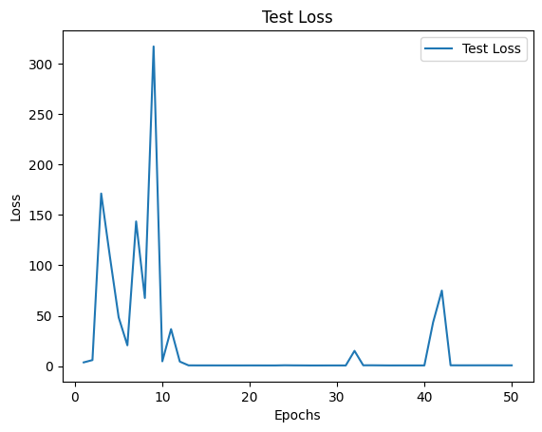

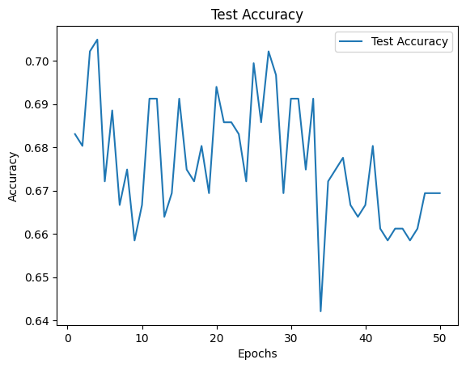

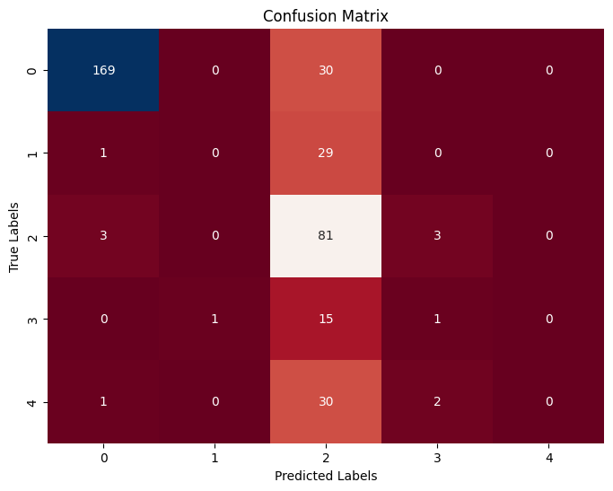

Fig2. Visual Geometric Group

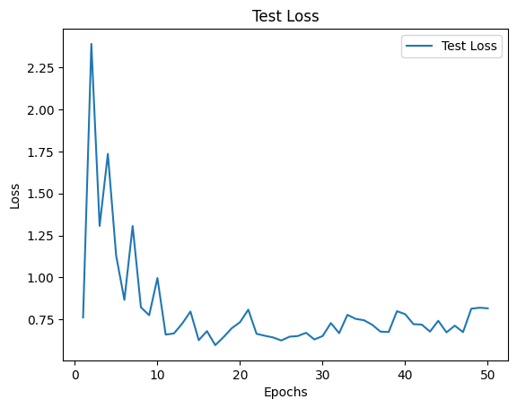

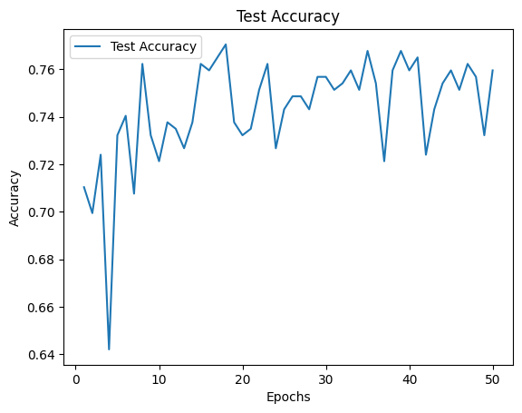

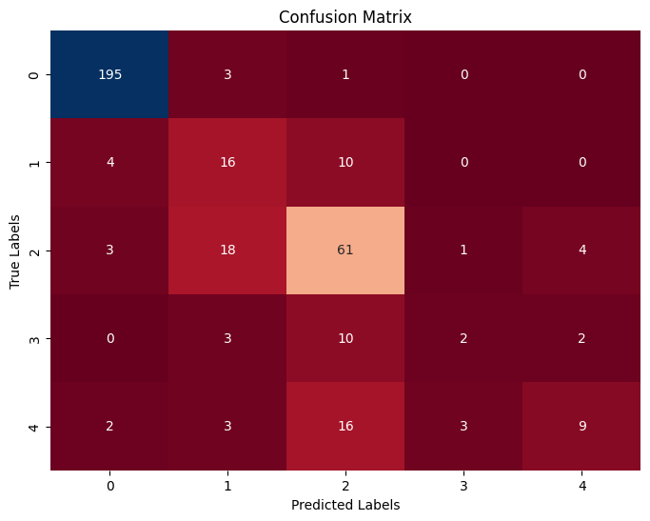

Fig3. Densenet

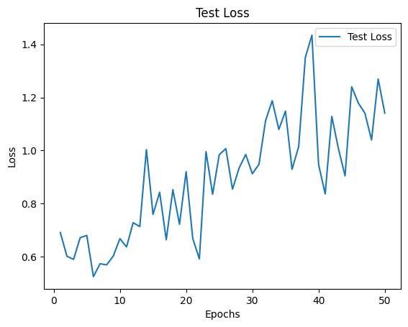

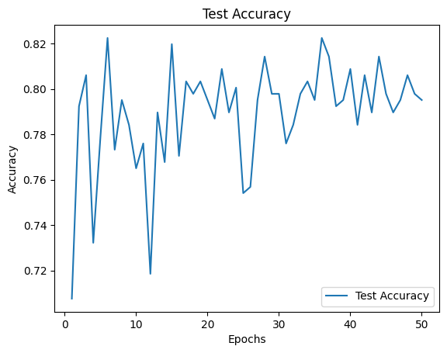

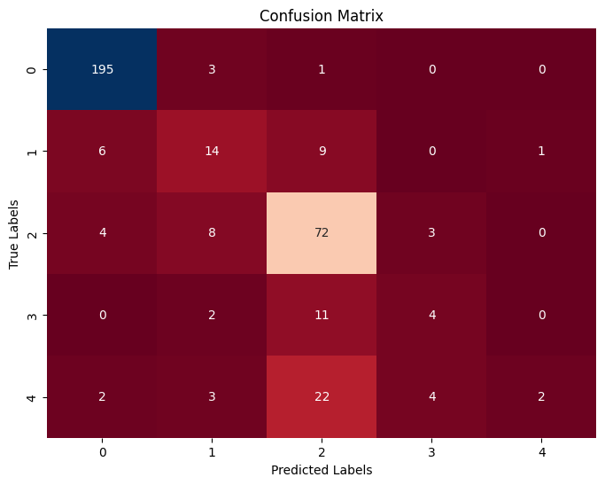

Fig3. Inception

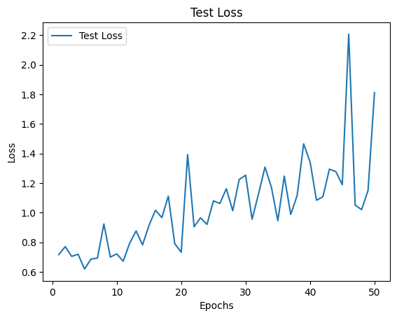

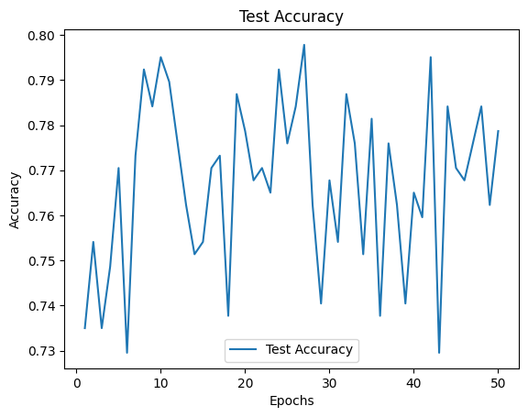

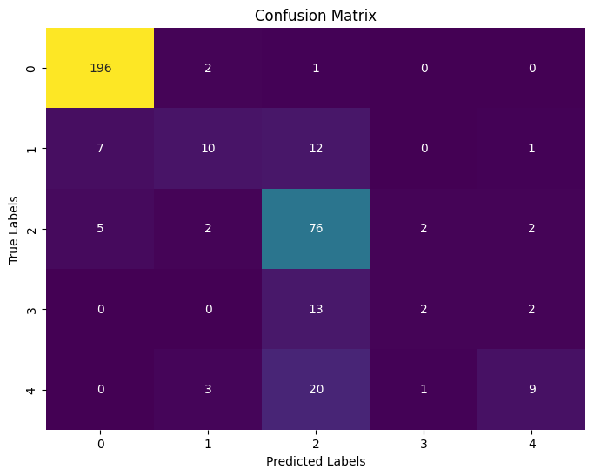

# Experimental Results

1. Convolutional Neural Network

|  |
| --- |
|  |
|  |
|  |
|  |
|  |

1. Visual Geometric Group

|  |
| --- |
|  |
|  |
|  |
|  |

1. Densenet

|  |
| --- |
|  |
|  |
|  |
|  |
|  |

1. Inception

|  |
| --- |
|  |
|  |
|  |
|  |
|  |

##### References

1. Al-Smadi, Mohammed, Mahmoud Hammad, Qanita Bani Baker, and A. Sa’ad. "A transfer learning with deep neural network approach for diabetic retinopathy classification." *International Journal of Electrical and Computer Engineering* 11, no. 4 (2021): 3492.
2. Deshpande, Abhishek, and Jatin Pardhi. "Automated detection of Diabetic Retinopathy using VGG-16 architecture." *Int Res J Eng Technol* 8, no. 03 (2021).
3. Wan, Shaohua, Yan Liang, and Yin Zhang. "Deep convolutional neural networks for diabetic retinopathy detection by image classification." *Computers & Electrical Engineering* 72 (2018): 274-282.
4. Aatila, Mustapha, Mohamed Lachgar, Hamid Hrimech, and Ali Kartit. "Diabetic retinopathy classification using ResNet50 and VGG-16 pretrained networks." *International Journal of Computer Engineering and Data Science (IJCEDS)* 1, no. 1 (2021): 1-7.
5. Alyoubi, Wejdan L., Wafaa M. Shalash, and Maysoon F. Abulkhair. "Diabetic retinopathy detection through deep learning techniques: A review." *Informatics in Medicine Unlocked* 20 (2020): 100377.
6. Doshi, Darshit, Aniket Shenoy, Deep Sidhpura, and Prachi Gharpure. "Diabetic retinopathy detection using deep convolutional neural networks." In *2016 international conference on computing, analytics and security trends (CAST)*, pp. 261-266. IEEE, 2016.
7. Yadav, Shefali, and Prashant Awasthi. "Diabetic retinopathy detection using deep learning and inception-v3 model." *Int. Res. J. Mod. Eng. Technol. Sci* 4 (2022): 1731-1735.
8. Mishra, Supriya, Seema Hanchate, and Zia Saquib. "Diabetic retinopathy detection using deep learning." In *2020 International Conference on Smart Technologies in Computing, Electrical and Electronics (ICSTCEE)*, pp. 515-520. IEEE, 2020.
9. <https://www.kaggle.com/competitions/aptos2019-blindness-detection>